## Western Australian Certificate of Education

**Semester 1 Examination, 2016**

##### 

**COMPUTER**

**SCIENCE**

**Unit 1: Year 11 ATAR**

**Source Booklet**

**This Information relates to Question 21 in Section Two (2).**

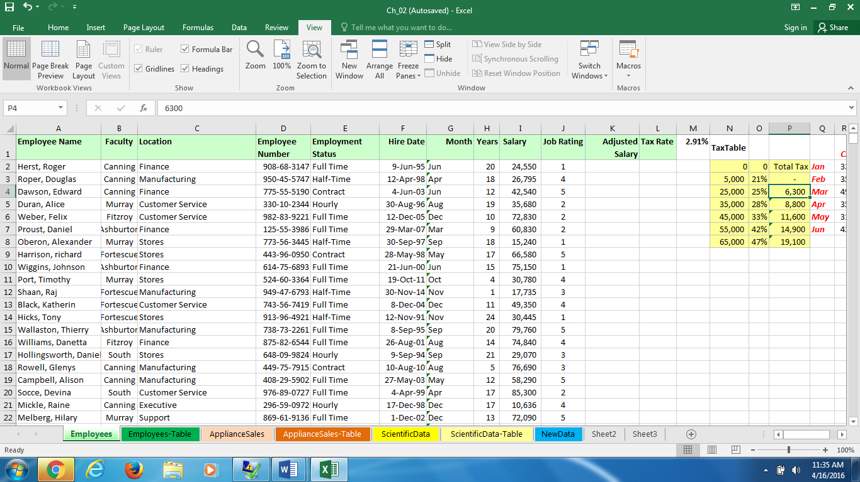**Source A – Spreadsheet Data Extract ABC Pty Ltd**

**This information relates to Question 22 in Section Two (2).**

**Source B**

The Human resources department is in charge of keeping track of all employees details. At present the information is stored in the spreadsheet listed above (Source A).

ABC Limited recruit for various departments spread across a variety of locations.

**Business rules**

1. An employee can work in only one Department
2. A Department can be spread across many Locations
3. A Location can have many departments
4. An employee is assigned to only one location

**This Information relates to Question 23 in Section Two (2).**

**Source C**

**ABC Pty Ltd** now wish to implement a new Human Resources management system to replace the series of spreadsheets that they current use and have contracted Fixem Pty Ltd to undertake this work.

ABC Pty Ltd have provided the following information:

1. The department that wishes to recruit contacts the Human Resources Department by emailing a Job Requirements form which outlines the particulars of the job including salary, department and location along with qualifications experience required for the position. These details will be stored in a filing cabinet ‘Current Positions’
2. The Human Resources Department will advertise the job details with the local employment agency and the local employment agency, after an advertising period, will send suitable resumes to the Human Resources Department.
3. After a vetting and security check, the Human Resources Department will send the details of a suitable resume to the recruiting department who will then advise whether they wish to interview applicant.
4. A successful applicant will be contacted directly by the Human Resources Department if their details are approved of by the recruiting department and an interview time will be scheduled.
5. The applicant will be advised of the interview time and will confirm their attendance. The recruiting department will then be advised of this interview time.
6. After the interview, the applicant will be advised whether they have got the job or not. If not, their details are stored on file for other suitable positions within ABC Pty Ltd. If they are offered the job, their acceptance is received within 2 working days and the department is notified.
7. Upon appointment, prospective employees provide details that includes their Tax File Number, Residential Address, Emergency contact number, Next of kin, email address and DOB. They are then allocated an employee identity card. This is stored in the Employee file
8. The Human Resources Department take a copy of the new employees personal details and send it to the department that requested the recruitment.

**End of Source Booklet**